Jesus answered, “I am the way and the truth and the life.
No one comes to the Father except through me.

John 14:6 (NIV)

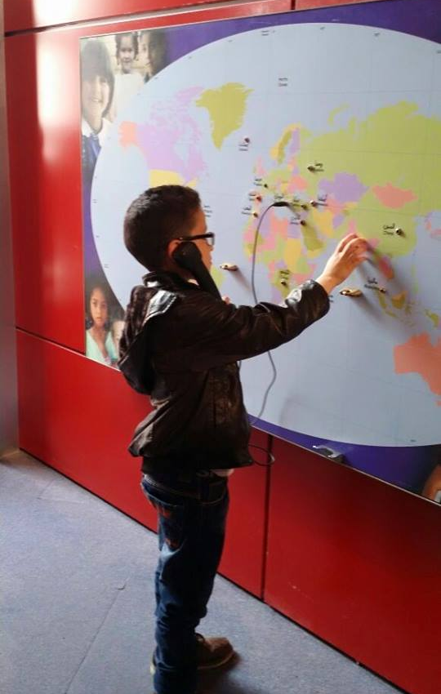
visit to museum

In April, the students from grade 4 to 6 visited the "Children's Museum" in Amman. The students were accompanied by six of our teachers and a volunteer and set off to Amman with one of our school buses. In the museum, the children were able to try a lot of different items - for example, a television show, classic cars, and toy planes. Then it was off to McDonalds.

The seventh grade visited a museum in April as well. Miss Maisa the geography teacher organized the trip and accompanied her students to the Jordanian Origin Museum. There, the students were able to learn a lot about native species and admire old artifacts.

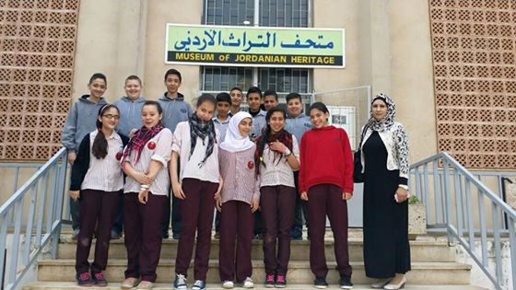

Inside this issue
VISIT TO MUSEUM 1
FUNDRAISING 2
SOCIAL INTELLIGENCE 2
TEACHER'S APPRECIATION 2
OPEN DAY 3
RECYLCING 3
TRAINING 4
ARABIC DAY 4
SIGHT CITY 5
CAR RALLY 5
DELF 5
GRADUATION 6
FAREWELL & WELCOME 7
THANK YOU 7

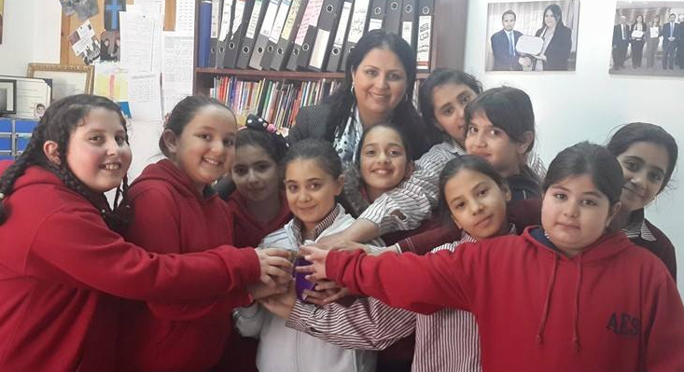
FUNDRAiSING
Students from grade 3 and 4 decided to purchase a piggy bank and bring it to their classroom and collect money for people less fortunate. The money raised was by voluntary donations and used to help the blind students of our school and their families.

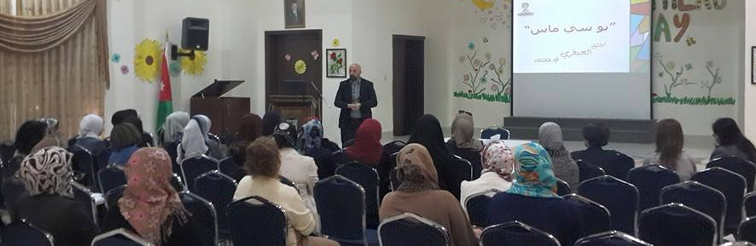
social intELLIGENCE
On April 18th Dr Dawlat Harb, one of our teachers, talked to our grade 4-6 students about Social Intelligence and the importance of it. They were informed that social interaction is key to their development and also important to live a healthy lifestyle.
On the same day Mr. Moataz Azar came to talk to the parents and teachers of our students about UCMAS Jordan – a program that is dedicated to enhancing children's lives by offering a unique program that contributes to children's mental health and development.

teacher's appreciation!
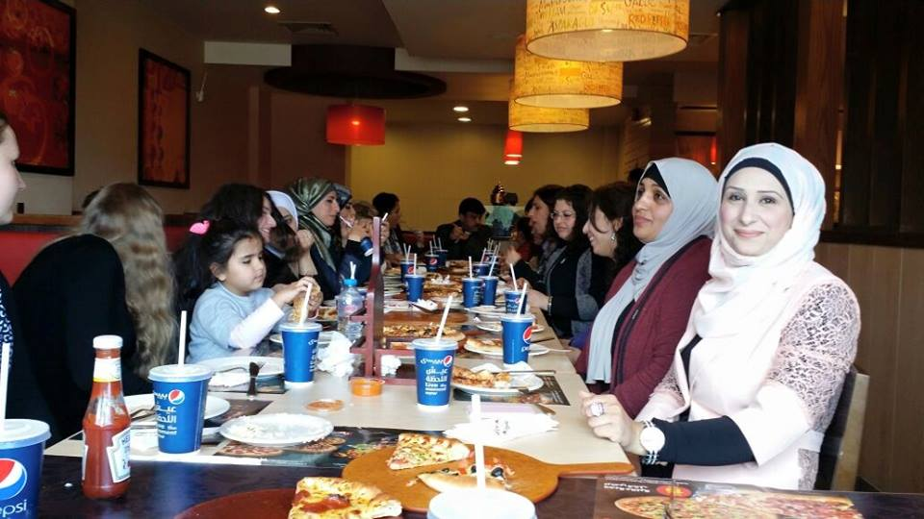
All teachers have been working throughout the school year with a lot of commitment and motivation. In appreciation for all their hard work and dedication headmistress Miss Sabah Zurikat and the school administrator Pastor Samir Esaid invited all the teachers after school out for dinner to Pizza Hut. It was a nice afternoon celebrating everyone's hard work and great company. The teachers are very much appreciated in our school for all their effort! A lot of time and energy goes in to planning their lessons daily, as part of our mission is to offer inclusive education to the visually impaired alongside the sighted students. We want to thank all our teachers for their amazing work and for walking this journey with us to educate our future generation here in Jordan.
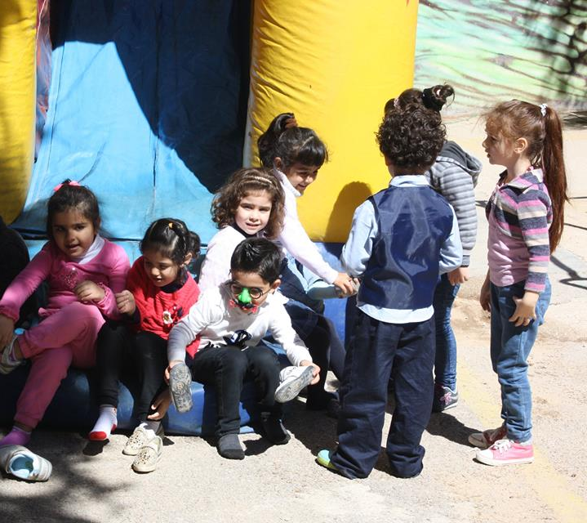

open day!

On Saturday 25th of April all the students and their families were invited to celebrate open day with us here at AES. The children enjoyed the inflatable slides, bouncy castle, face paint, and 3D movie. There was also music, many different dances, and games. Popcorn, corn or sandwiches could be bought at one of the concession stands. The highlight however for this year was the magic show! All the students, parents and teachers enjoyed open day and all that came with it!

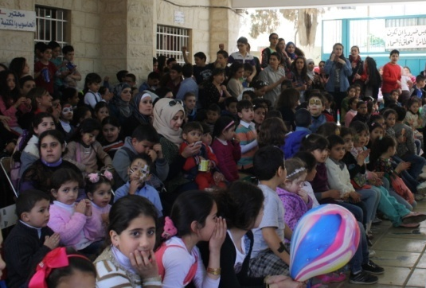
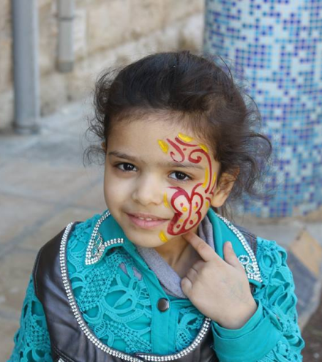
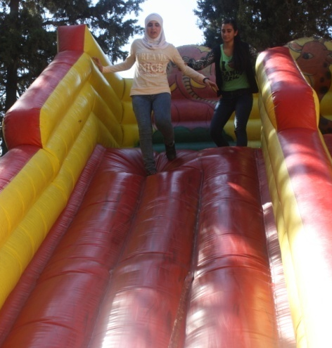

RECYCLING
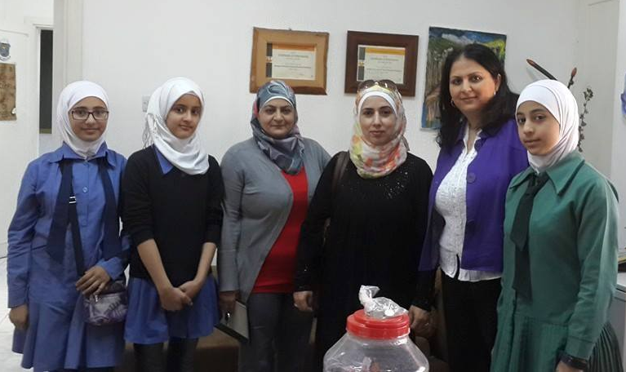
The staff and students at the Nusiba Al Mazeneh Irbid Government School helped all of us here at AES recycle. We believe recycling to be very important for our environment and a valuable thing to teach our students. A special thanks to Sarah, who used to be a student at AES, for including her peers and teachers in this project at her new school and for promoting recycling to better our environment.
TRAINING
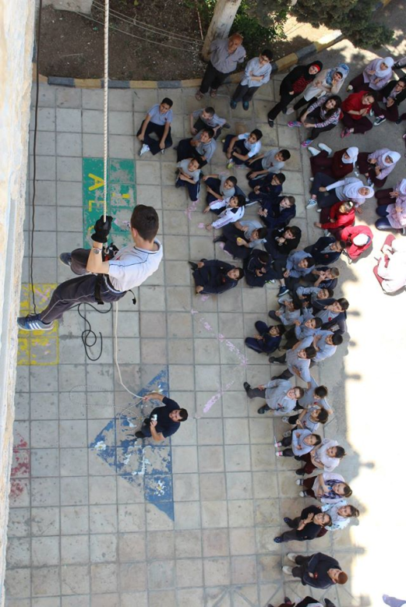
Cliff Eagles, a team from Amman, that educates people how to safely propel down a building during an emergency came to our school upon invitation on May 5th to show our students how to evacuate the school in case of fire alarm or other emergency . Several students, as well as two of our volunteers went up to the roof and propelled down along the side of the building making it safely to the ground.
Cliff Eagles also does various sport activities in Jordan with groups of all ages. This event at our school was not only for safety reasons but also to help the students to overcome their fear of heights.
As the excitement level among the students was high we are now considering taking the students camping during their summer holidays in the Jordan Valley.

ARABIC DAY

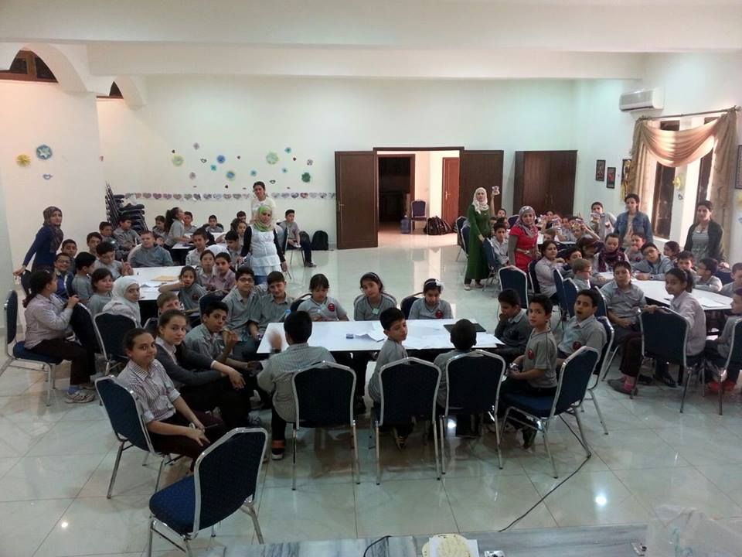
On the 16th of May students from grade 4 to 6 were divided into groups and participated in an Arabic language quiz. This is to teach the importance of the Arabic language to all our students. They were supervised by their Arabic teacher Miss Eklas Bani Hani, our librarian Miss Huda Massad and our administrator Dr Dawlat Harb. Gifts were distributed to all the students and certificates were given to the winning group. The event was sponsored by Al-Hayat Publishing.
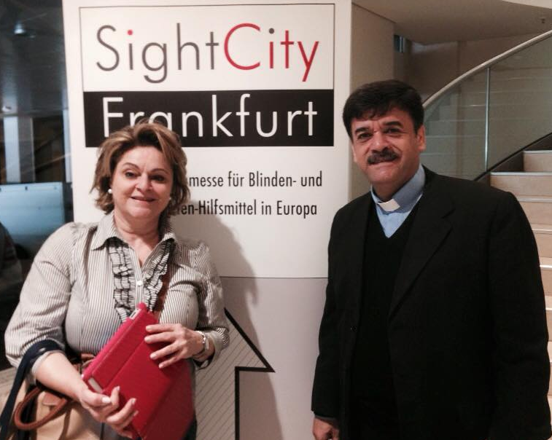
SIGHT CITY
In May our school administrator Reverend Samir Esaid traveled to Frankfurt Germany along with Dr. Amal Nahhas, who is "Sec. General at Higher Council for People with Disabilities". She is the personal assistant to Prince Mired Ka'ad Zeid Al-Hussein, who is responsible for persons with disabilities in Jordan. They visited the "Sight City" exposition to get new ideas on how to further improve the education for the blind and visually impaired people in Jordan.

CAR RALLY

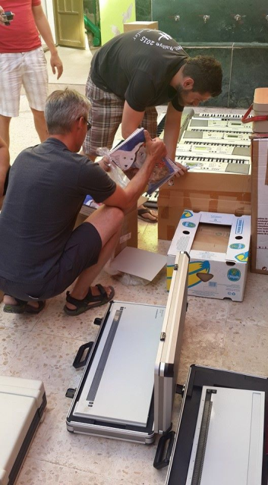
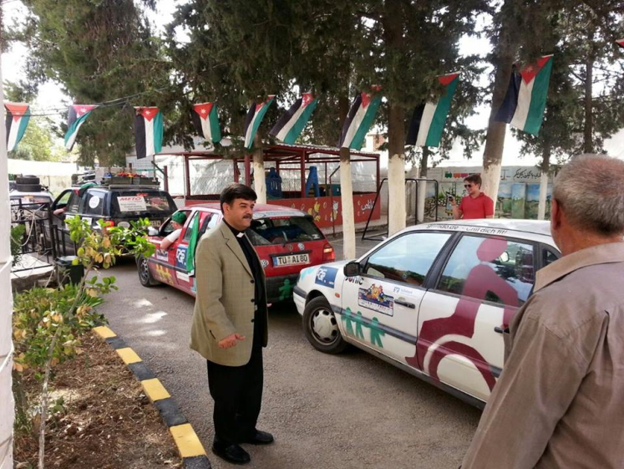
On May 10 this year, 550 participants along with more than 200 cars made their way from Germany to Jordan. After 16 eventful days they finally crossed over the Jordanian border. May 28th three of the teams along with eight cars took the time to visit AES; along with them were, Tobias Ostertag and Tatjana Bruns. Reverend Samir Esaid arranged for these teams to bring a few donation items from Germany for AES before the start of the rally. Thanks to them we now have eight new keyboards, German student books for the next school year, games and clothes. The cars of the rally are sold each year in Jordan and the proceeds will be donated to various charities. We hope that next year the Rally will once again make its way down to us here at AES.

DELF
On June 4th the grade 6 and grade 9 students participated in an international DELF-exam. Three of our students received excellent marks. We are very proud of their accomplishments!
KINDERGARTEN GRADUATION!

On June 4th the Arab Episcopal School celebrated the biggest celebration of the school year: Graduation Day! As always, the graduation was celebrated in honor of the Kindergarten 2 children who will attend the first grade after the summer holidays.
But this year we added the 10th grade students, as their time with us here at AES has come to an end.
Since this is about the students, with whom it all began twelve years ago, the celebration was especially emotional. Taqwa, the first blind student who was accepted at the AES, held a touching closing speech.
The Arch Bishop of the Anglican Church in the Middle East, Suheil Dawani, arrived specially for the festival, directed a few words to the assembled audience, as well as Reverend Samir Esaid and Headmistress Miss Sabah Zurikat. To celebrate the Kindergartners success, a few of the older students danced the traditional Jordanian and Palestinian dance called "Dabkeh," while other classes sang in the choir both in Arabic and English.
After the great celebration, each of the kindergarten children was called individually and received a diploma with an award. Pride filled teachers, parents and children, congratulated and visited with each other after the great celebration. The students full of anticipation were then dismissed for their summer vacation, and are greatly looking forward to entering grade 1 next year!
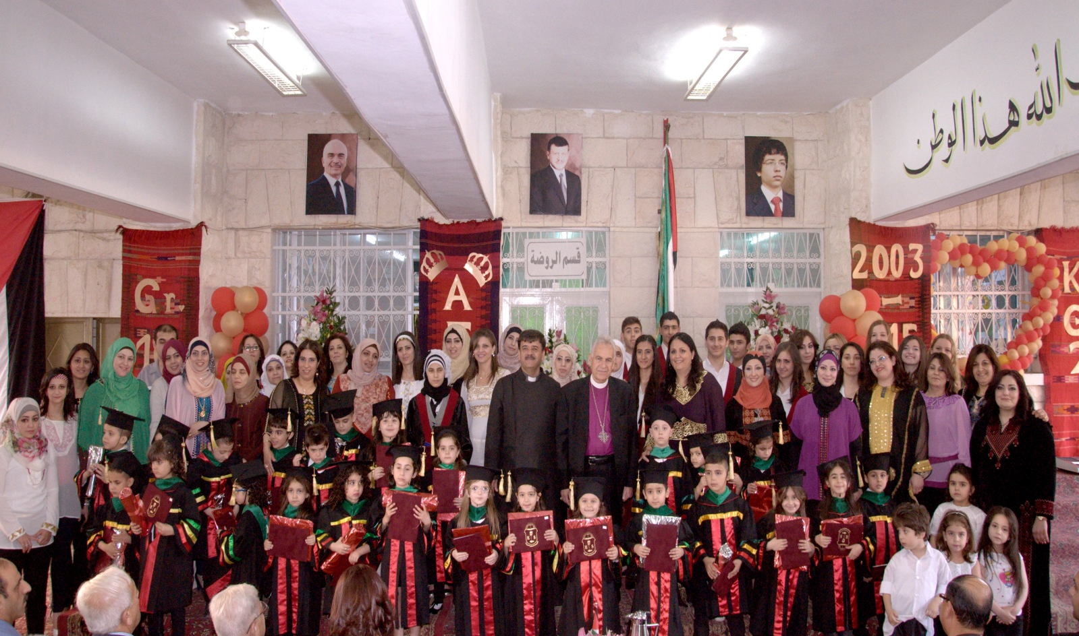
FAREWELL &WELCOME!
For this year, we want to say farewell to all the students who will leave AES, specially the grade 10 students who are moving on to other schools as we can't continue their education at this time. We wish them all the best for their future and know they will succeed!
We would also like to say farewell to our four volunteers Betty Sawatzky, Henriette Haney, Johanna Rave, and Verena Mittelbach. We are grateful for all the support and creativity they brought to the school this past year. Big thanks to them for all their work. We also wish them all the best, and God's blessing for the future.
But every goodbye always brings something new: we welcome all the new students for the coming year!
We also welcome the new volunteers Carissa Crane from the United States and Anke Momm and Carlotta Cohnen from Germany! We are looking forward to working together and to the 2015-2016 school year!
My help comes from the Lord,
the Maker of heaven and earth.

Psalm 121:2 (NIV)

Thank you!
We hope that this newsletter finds all of you well and want to take a moment to thank all our partners and supporters throughout the 2014-2015 school year for all your donations, support and encouragement throughout the year. Wishing all of you a wonderful summer holiday!

For more information please visit our website at: www.aeschool.org or our Facebook page at: www.facebook.com/ArabEpiscopalSchool.
Arab Episcopal School
P.O. Box 765
Irbid 211 10
Jordan
e-mail: stjohn_b@hotmail.com

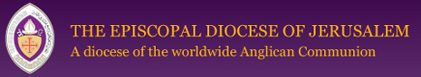

Arab Episcopal School is a part of the Diocese of Jerusalem the Episcopal Church in Jerusalem & the Middle East.
For more information please visit: www.j-diocese.org

